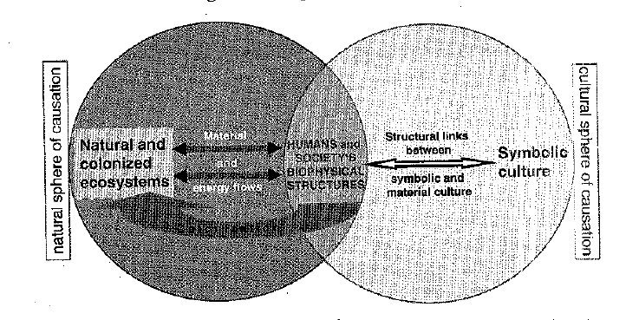

3. What types of evidence exist for past ecosystems and what do they reveal about changes in the landscape?

2. How does symbolic culture, i.e. chronicle writing, influence human society, and the structures/institutions it creates? How do you see such cultural productions impacting activities like crusading?

4. In what ways do the structures and institutions discussed in 2 impact the environment. Can you see how the impact of crusading might differ from the activities of local pagan society?

1.Can you think of other examples of culture that might impact how humans interact with their environment?